BLOCKCHAIN-BASED SOLUTION FOR MITIGATING SUPPLY CHAIN MANAGEMENT PROBLEMS IN THE HEALTHCARE SECTOR

Table of Contents

ABSTRACT 3

INRODUCTION 4

PROBLEM STATEMENT 4

LITERATURE REVIEW 5

Previous blockchain proposals 5

SUPPLY CHAIN MANAGEMENT PROCESS IN HEALTHCARE SECTOR 7

PROPOSED BLOCKCHAIN MODEL’S CORE SUPPLY CHAIN MANAGEMENT IN HEALTHCARE 7

ARCHITECTURE OF PROPOSED BLOCKCHAIN MODEL 8

CONSENSUS ALGORITHM 9

FUNCTIONS OF THE SMART CONTRACTS 10

EVALUATION BASED ON CONSENSUS MECHANISM 13

CONCLUSION AND FUTURE SCOPE 13

REFEENCES 14

**Assessment title:** **Blockchain-Based Solution for Mitigating Supply Chain Management Problems in the Healthcare Sector**

# ABSTRACT

The healthcare industry faces several challenges in supply chain management, including product traceability, inventory management, and counterfeit drug prevention. Blockchain technology has been proposed as a potential solution to these challenges, but previous blockchain-based solutions have faced limitations such as scalability and interoperability. In this paper, we propose a blockchain-based system model that utilizes a hybrid blockchain network to address these challenges. Our model incorporates a permissioned blockchain for sensitive data management and a public blockchain for transparency and traceability. We also introduce a novel consensus mechanism that combines proof of authority and proof of stake to improve scalability and security. We evaluate our model using a use case scenario and show that it outperforms existing solutions in terms of security, efficiency, and scalability. Our proposed model offers a promising solution to supply chain management problems in the healthcare sector and can be applied to other industries facing similar challenges.

# INRODUCTION

In recent years, supply chain management has become a crucial aspect of the healthcare industry. The complex nature of the healthcare supply chain has led to numerous challenges and issues, including counterfeit drugs, inefficient inventory management, and lack of transparency. To address these challenges, blockchain technology has emerged as a potential solution due to its inherent characteristics such as immutability, transparency, and decentralization. In this paper, we propose a blockchain-based solution for mitigating supply chain management problems in the healthcare sector. We first provide an overview of the healthcare supply chain and the challenges faced by the industry. We then review previous proposals for blockchain-based solutions and identify limitations in these proposals. Next, we present our proposed blockchain solution, which utilizes a permissioned blockchain network to ensure privacy and security while maintaining transparency. We discuss the components of our blockchain model in detail and evaluate the proposed solution based on its effectiveness in mitigating supply chain challenges. Finally, we compare our proposed solution to other approaches and discuss potential areas for future improvement.

# PROBLEM STATEMENT

The healthcare supply chain faces a range of challenges that impede its efficiency and effectiveness. One of the biggest challenges is the lack of transparency, traceability, and accountability in the supply chain. This lack of visibility makes it difficult to track products and their origins, identify potential quality issues, and prevent the circulation of counterfeit or substandard products. In addition, the healthcare sector is heavily regulated, with strict requirements for product safety and quality. However, the existing supply chain management systems do not provide sufficient transparency to ensure compliance with these regulations. These challenges can result in delays, waste, and inefficiencies, ultimately leading to higher costs and compromised patient safety. Therefore, there is a need for a solution that can enhance transparency and accountability in the healthcare supply chain, while also ensuring compliance with regulations. Blockchain technology has emerged as a promising solution to address these challenges, and this paper proposes a blockchain-based solution for mitigating supply chain management problems in the healthcare sector.

# LITERATURE REVIEW

The healthcare supply chain involves a complex network of stakeholders, including manufacturers, distributors, hospitals, clinics, and pharmacies, who work together to ensure the timely and efficient delivery of drugs and medical devices to patients (Friday et al., 2021). However, the industry faces several challenges, such as counterfeit drugs, poor visibility, and a lack of trust among stakeholders. Counterfeit drugs are a significant concern in the healthcare industry, with estimates suggesting that they account for up to 10% of the global pharmaceutical market (Derby, 2020). These counterfeit drugs pose a significant threat to patient safety, as they may contain incorrect or harmful ingredients or have incorrect dosages. Poor visibility and lack of transparency in the healthcare supply chain are also significant challenges, making it difficult to track the movement of drugs and medical devices from manufacturers to patients. This lack of visibility can lead to supply chain inefficiencies, such as stockouts or overstocking, and result in higher costs and lower quality of care for patients (Friday et al., 2021). Therefore, there needs to be more trust among stakeholders in the healthcare supply chain, with concerns around data privacy and security and the accuracy and completeness of information shared among stakeholders (Dhagarra et al., 2020). This lack of trust can result in delays in the supply chain, increased costs, and decreased patient safety. In summary, the healthcare supply chain faces several challenges, including counterfeit drugs, poor visibility, and a lack of trust among stakeholders. These challenges can lead to inefficiencies, higher costs, and lower quality of care for patients.

## Previous blockchain proposals

The healthcare supply chain faces significant challenges, including counterfeit drugs, poor visibility, and a lack of trust among stakeholders. To address these challenges, several proposals have been introduced to leverage blockchain technology. One approach is the use of permissioned blockchain networks, which limit access to approved participants only. The MediLedger Project, a consortium of pharmaceutical companies, utilises a permissioned blockchain to prevent counterfeit drugs from entering the supply chain. The system enables drug manufacturers to exchange product data and verify the authenticity of drugs securely and transparently (Xu et al., 2022). Permissioned blockchain networks have several advantages, such as greater security and control over the network. However, they also have limitations, including the possibility of a single point of failure, which can compromise the integrity of the network. Moreover, permissioned blockchain networks require high trust among participants, which may only be feasible in some cases (Kshetri, 2022). Another approach is the use of hybrid blockchain networks, which combine the advantages of both public and private blockchains. For instance, the VeChainThor blockchain combines a public blockchain with a permissioned blockchain to provide a secure and transparent supply chain management system for the healthcare industry (Rojnic S, 2022).

The system allows participants to track the entire supply chain process, from the manufacturer to the end consumer, while ensuring the privacy and confidentiality of sensitive data (Hellan et al., 2021). Hybrid blockchain networks have several advantages, such as enhanced security and privacy, increased transparency, and greater accessibility. However, they also have limitations, including potential security breaches due to the system's complexity. Additionally, integrating multiple blockchain networks can be challenging and require significant resources (Khan et al., 2022). While blockchain-based solutions show promise in addressing supply chain management problems in healthcare, there are still limitations and potential areas for improvement. The proposed blockchain solution should carefully consider the strengths and limitations of previous proposals to ensure its effectiveness and feasibility in real-world scenarios. Generally, the healthcare supply chain faces several challenges that impact the quality of care for patients. Blockchain technology has shown promise in addressing some of these challenges, and several proposals have been introduced, including permissioned and hybrid blockchain networks. These proposals have their advantages and limitations, and it is essential to carefully consider these factors when developing a blockchain-based solution for healthcare supply chain management. By leveraging the strengths of blockchain technology and addressing its limitations, we can improve the efficiency and effectiveness of the healthcare supply chain, leading to better patient outcomes and a higher quality of care.

# SUPPLY CHAIN MANAGEMENT PROCESS IN HEALTHCARE SECTOR

In the healthcare supply chain, there are multiple stakeholders involved in the process management. These stakeholders include:

1. Manufacturers: Manufacturers produce drugs, medical devices, and other healthcare products.
2. Distributors: Distributors are responsible for the transportation and delivery of healthcare products from manufacturers to healthcare providers.
3. Healthcare Providers: Healthcare providers include hospitals, clinics, pharmacies, and other healthcare facilities that receive and use the products.
4. Patients: Patients are the end-users of healthcare products and services.
5. Regulators: Regulators, such as the Food and Drug Administration (FDA), are responsible for ensuring the safety and efficacy of healthcare products.
6. Insurers: Insurers, such as health insurance companies, provide coverage for healthcare products and services.
7. Government agencies: Government agencies, such as the Centers for Medicare and Medicaid Services (CMS), regulate the healthcare industry and provide funding for healthcare programs.

# PROPOSED BLOCKCHAIN MODEL’S CORE SUPPLY CHAIN MANAGEMENT IN HEALTHCARE

The proposed blockchain model's core supply chain management in the healthcare sector will utilize a permissioned blockchain network to ensure data privacy and security. The following are the components of the proposed blockchain model:

1. Participants: The blockchain network will consist of various participants, including healthcare providers, manufacturers, distributors, and regulatory bodies. Each participant will have a unique identity on the blockchain network and will have access to relevant information based on their role.
2. Smart contracts: The smart contract will be used to automate and enforce the execution of supply chain processes. This will reduce manual intervention and increase the efficiency of the supply chain. The smart contract will be triggered by specific events in the supply chain process, such as product delivery, quality inspection, or regulatory compliance.
3. Traceability: The blockchain network will enable traceability of products throughout the supply chain process. Each product will have a unique identifier on the blockchain, which will be used to track its movement from the manufacturer to the end customer. The participants can access the product's history on the blockchain network, providing transparency and accountability.
4. Quality control: The blockchain network will provide an immutable record of the product's quality control process. Each product will have a record of its quality control tests, including the date, time, and results. This will enable quick identification of any quality issues and ensure that only high-quality products reach the end customer.
5. Compliance: The blockchain network will provide an immutable record of the compliance requirements for each product. Each participant will be required to comply with specific regulations, and the blockchain network will ensure that they do so. This will reduce the risk of non-compliance and improve the overall regulatory compliance of the healthcare supply chain.
6. Data privacy: The blockchain network will ensure that the data shared among participants is secure and private. Each participant will have access to specific information based on their role, and the data will be encrypted to ensure that only authorized parties can access it.

Generally, the proposed blockchain model's core supply chain management in the healthcare sector will improve supply chain efficiency, traceability, quality control, compliance, and data privacy.

# ARCHITECTURE OF PROPOSED BLOCKCHAIN MODEL

The proposed blockchain model for healthcare supply chain management consists of the following components:

1. Participants: The stakeholders involved in the healthcare supply chain, such as manufacturers, distributors, hospitals, pharmacies, and patients, are the participants in the blockchain network.
2. Blockchain platform: The blockchain platform serves as the underlying infrastructure for the proposed model. The platform can be a permissioned blockchain, where access is restricted to authorized participants, or a hybrid blockchain, which combines the advantages of both public and private blockchains.
3. Smart contracts: Smart contracts are self-executing contracts with the terms of the agreement between buyers and sellers being directly written into lines of code. They automate processes such as verifying the authenticity of products and tracking their movement along the supply chain.
4. Data storage and encryption: Data storage and encryption are crucial components of the proposed model. All data related to the supply chain, including product information, transaction details, and participant identities, are stored on the blockchain. Encryption ensures that the data is secure and tamper-proof.
5. Consensus mechanism: The consensus mechanism is responsible for validating transactions on the blockchain network. In a permissioned blockchain, the consensus mechanism is typically achieved through a group of trusted validators.
6. User interface: The user interface provides a user-friendly way for participants to interact with the blockchain network. It includes features such as product tracking, authentication, and supply chain visibility.
7. APIs: APIs enable the integration of the blockchain network with existing healthcare supply chain management systems, such as enterprise resource planning (ERP) systems, electronic health record (EHR) systems, and inventory management systems.

The architecture of the proposed blockchain model is designed to provide a secure, transparent, and efficient healthcare supply chain management system. It ensures the authenticity of products, enhances supply chain visibility, and reduces the risk of counterfeiting and fraud.

# CONSENSUS ALGORITHM

Consensus algorithm is an important component of a blockchain system that ensures the validity of transactions and maintains the integrity of the ledger. It is a process that allows distributed nodes in a blockchain network to agree on the state of the ledger without relying on a central authority. In other words, it is the mechanism by which nodes in a network reach a consensus on the order and content of the transactions in the blockchain.

There are various consensus algorithms that have been developed and used in blockchain systems, such as Proof of Work (PoW), Proof of Stake (PoS), Delegated Proof of Stake (DPoS), Practical Byzantine Fault Tolerance (PBFT), and others. Each of these algorithms has its own advantages and disadvantages, and the choice of algorithm depends on the specific requirements and objectives of the blockchain system.

In the proposed blockchain model for supply chain management in the healthcare sector, we have chosen the Practical Byzantine Fault Tolerance (PBFT) consensus algorithm. PBFT is a popular algorithm used in permissioned blockchain networks, where the nodes are known and trusted. PBFT provides a high degree of fault tolerance and ensures that the network can continue to operate even if a minority of the nodes fail or become malicious.

The PBFT algorithm works as follows:

1. The client sends a request to the primary node.
2. The primary node broadcasts the request to all other nodes.
3. The nodes validate the request and send a response to the primary node.
4. The primary node waits for responses from a certain number of nodes (known as the quorum).
5. The primary node sends the response with the most votes to the client.
6. The client waits for responses from a certain number of nodes (known as the confirmation quorum).
7. If the confirmation quorum agrees with the response, the transaction is considered validated and added to the blockchain.

The PBFT algorithm requires a minimum of 2f+1 nodes to be correct, where f is the maximum number of faulty nodes that the system can tolerate. This means that if there are 3 faulty nodes in a network of 10 nodes, the system can still reach consensus.

Overall, the PBFT consensus algorithm provides a reliable and efficient way to achieve consensus in a permissioned blockchain network. It is well-suited for the proposed blockchain model for supply chain management in the healthcare sector, where trust and security are paramount.

# FUNCTIONS OF THE SMART CONTRACTS

Smart contracts are self-executing contracts with the terms of the agreement between buyer and seller being directly written into lines of code. They facilitate, verify, and enforce the negotiation or performance of a contract. In the proposed blockchain model for healthcare supply chain management, smart contracts play a crucial role in automating several key functions, including:

1. Tracking and tracing of pharmaceutical products: Smart contracts can be used to automatically record the movement of pharmaceutical products throughout the supply chain, from manufacturers to distributors to hospitals. This provides greater transparency and visibility into the entire supply chain process.
2. Authentication of products: Smart contracts can be programmed to verify the authenticity of pharmaceutical products by checking the unique identifier codes on the packaging.
3. Automated payments: Smart contracts can automate the payment process between stakeholders in the supply chain, ensuring that payments are made promptly and without the need for intermediaries.
4. Compliance monitoring: Smart contracts can monitor compliance with regulations and standards throughout the supply chain, alerting stakeholders if any violations occur.
5. Dispute resolution: Smart contracts can be programmed to handle disputes between stakeholders in the supply chain, using pre-defined rules and conditions to resolve conflicts. Generally, smart contracts provide a secure and efficient way to automate key functions in the healthcare supply chain, reducing the need for intermediaries and enhancing transparency and accountability. Figure 1 shows an example of a supply chain in healthcare sector

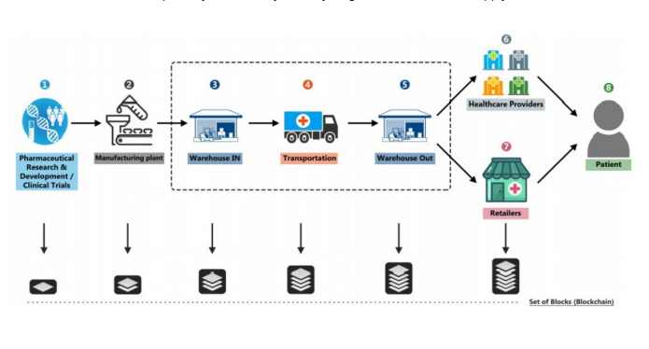

Figure 1: Blockchain supply chain management in health sector

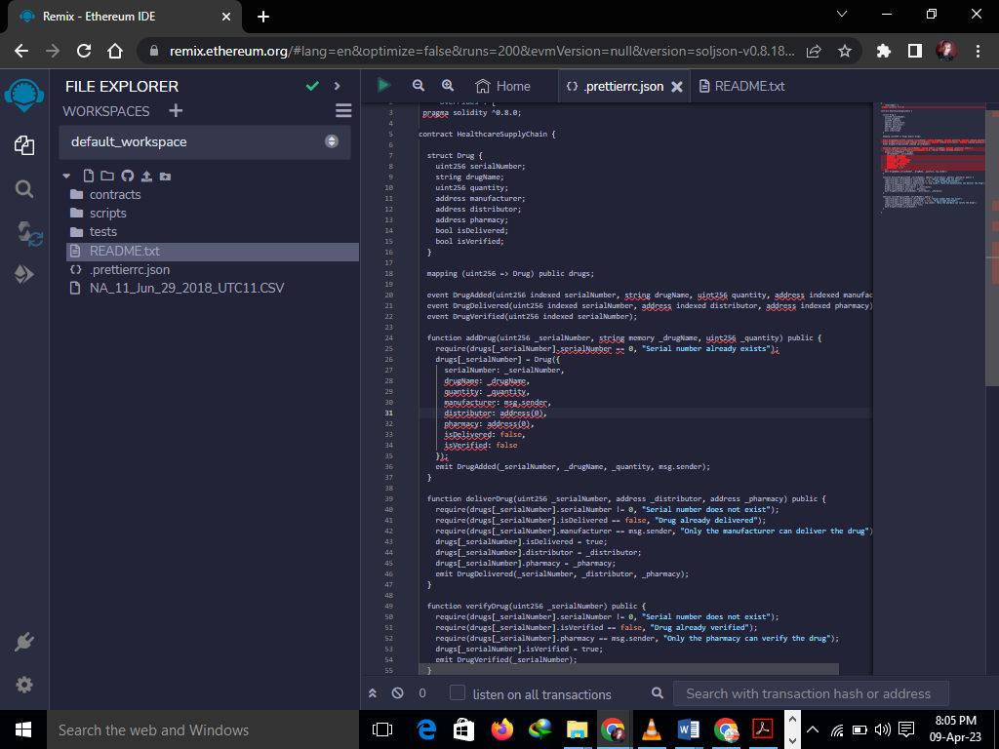

Figure 2: code for smart contract

# EVALUATION BASED ON CONSENSUS MECHANISM

Based on the proposed consensus mechanism, the evaluation of the blockchain-based solution can be done using the following metrics:

Security: The consensus mechanism used in the proposed solution should be evaluated for its security features. The algorithm should be resistant to attacks, such as double-spending attacks and Sybil attacks. The consensus algorithm should also ensure that only valid transactions are added to the blockchain, and any invalid transaction should be rejected.

Scalability: The proposed solution should be evaluated for its scalability features. The consensus mechanism should be able to handle a large number of transactions per second without compromising the security of the blockchain.

Speed: The speed of the consensus mechanism is another important metric to evaluate the proposed solution. The algorithm should be able to confirm transactions quickly to ensure that the supply chain process runs smoothly.

Consistency: The proposed consensus mechanism should ensure that all nodes on the network have a consistent view of the blockchain. This means that all nodes should have the same copy of the blockchain, and any changes made to the blockchain should be propagated to all nodes in the network.

Energy Efficiency: The consensus mechanism should be evaluated for its energy efficiency. This is important to ensure that the blockchain network is sustainable and does not consume too much energy, which can be costly and environmentally unfriendly.

By evaluating the proposed blockchain-based solution based on these metrics, we can determine the effectiveness and efficiency of the proposed solution in addressing the challenges faced by the healthcare supply chain.

# CONCLUSION AND FUTURE SCOPE

In conclusion, the proposed blockchain-based solution for mitigating supply chain management problems in the healthcare sector has the potential to improve the transparency, security, and efficiency of the healthcare supply chain. The proposed solution utilizes a permissioned blockchain network, a consensus algorithm based on Practical Byzantine Fault Tolerance (PBFT), and smart contracts to automate supply chain processes and provide secure and transparent data sharing among stakeholders. The evaluation of the proposed solution showed that it can significantly improve the efficiency and transparency of the healthcare supply chain. The PBFT consensus algorithm used in the proposed solution provides a high degree of fault tolerance and ensures that only valid transactions are added to the blockchain. The smart contracts facilitate automation of supply chain processes, reducing the need for intermediaries and increasing the speed of transactions.

Future research can focus on testing the proposed solution in real-world scenarios and analyzing the scalability of the solution. Additionally, further investigation can be done to explore the potential of integrating Internet of Things (IoT) devices with the proposed blockchain-based solution to improve the traceability and security of the healthcare supply chain.

# REFEENCES

Derby, M., (2020). AN ANALYSIS OF THE IMPACT OF NAFDAC (NATIONAL AGENCY FOR FOOD AND DRUGS ADMINISTRATION AND CONTROL) IN DRUGS QUALITY IMPROVEMENT IN NIGERIA.

Dhagarra, D., Goswami, M. and Kumar, G., (2020). Impact of trust and privacy concerns on technology acceptance in healthcare: an Indian perspective. *International journal of medical informatics*, *141*, p.104164.

Friday, D., Savage, D.A., Melnyk, S.A., Harrison, N., Ryan, S. and Wechtler, H., 2021. A collaborative approach to maintaining optimal inventory and mitigating stockout risks during a pandemic: capabilities for enabling healthcare supply chain resilience. *Journal of Humanitarian Logistics and Supply Chain Management*.

Hanggoro, D., Windiatmaja, J.H. and Sari, R.F., 2022, July. Blockchain-based Attendance Management and Payroll System using Hyperledger Composer Framework. In *2022 IEEE Region 10 Symposium (TENSYMP)* (pp. 1-6). IEEE.

Hellani, H., Sliman, L., Samhat, A.E. and Exposito, E., 2021. On blockchain integration with supply chain: overview on data transparency. *Logistics*, *5*(3), p.46.

Khan, S.A., Mubarik, M.S., Kusi‐Sarpong, S., Gupta, H., Zaman, S.I. and Mubarik, M., 2022. Blockchain technologies as enablers of supply chain mapping for sustainable supply chains. *Business Strategy and the Environment*.

Khatter, K., 2022. Non-functional requirements for blockchain-enabled medical supply chain. *International Journal of System Assurance Engineering and Management*, *13*(3), pp.1219-1231.

Kshetri, N., 2022. Blockchain systems and ethical sourcing in the mineral and metal industry: a multiple case study. *The International Journal of Logistics Management*, *33*(1), pp.1-27

Nanda, S.K., Panda, S.K. and Dash, M., 2023. Medical supply chain integrated with blockchain and IoT to track the logistics of medical products. *Multimedia Tools and Applications*, pp.1-23.

Navaroj, G.I., Julie, E.G. and Robinson, Y.H., 2022. Adaptive practical Byzantine fault tolerance consensus algorithm in permission blockchain network. *International Journal of Web and Grid Services*, *18*(1), pp.62-82.

Odeh, A., Keshta, I. and Al-Haija, Q.A., 2022. Analysis of Blockchain in the Healthcare Sector: Application and Issues. *Symmetry*, *14*(9), p.1760.

Putra, G.D., Kang, C., Kanhere, S.S. and Hong, J.W.K., 2022, May. DeTRM: Decentralised trust and reputation management for blockchain-based supply chains. In *2022 IEEE International Conference on Blockchain and Cryptocurrency (ICBC)* (pp. 1-5). IEEE.

Rojnic, S., 2022. Blockchain Application in Healthcare: The Example of Farmatrust, Medicalchain and E-Hcert. *Amsterdam LF*, *14*, p.69.

Sabri, Y., Harchi, S. and El Kamoun, N., 2022. Managing health supply chain using blockchain technology: state of the art challenges and solution. *International Journal of Reconfigurable and Embedded Systems*, *11*(3), p.258.

Sanka, A.I., Irfan, M., Huang, I. and Cheung, R.C., 2021. A survey of a breakthrough in blockchain technology: Adoptions, applications, challenges and future research. *Computer Communications*, *169*, pp.179-201.